**VIZORA  
AI-Powered Excel Analytics Web Application  
  
By**Utsav Modi  
  
*In association with***Zidio Technologies (1-Month Internship)**

**Abstract**

Vizora is an intelligent web analytics platform designed to simplify data visualization, chart generation, and insights extraction from Excel and CSV files. The application supports a wide range of chart types including 2D and 3D visualizations, along with an AI-powered chat assistant that helps users analyze trends, detect outliers, and generate recommendations.  
  
Built using modern technologies such as React.js, Node.js, and MongoDB, Vizora ensures a fast, responsive, and secure environment for users. It includes features like JWT-based login, profile management, history tracking, theme toggling, and an admin dashboard for managing users and monitoring system activity. This project demonstrates how modern web tools and artificial intelligence can democratize data analytics for non-technical users and professionals alike.

**Table of Contents**

|  |  |  |
| --- | --- | --- |
| Chapter | Title | Page no. |
| 1 | Project Overview | 1 |
| 2 | Core Features | 2 |
| 3 | Technology Stack | 5 |
| 4 | System Architecture | 6 |
| 5 | User Flow | 8 |
| 6 | Data Management & Security | 10 |
| 7 | Chart Types Supported | 12 |
| 8 | Screenshots (UI Previews) | 13 |
| 9 | Challenges Faced | 19 |
| 10 | Future Enhancements | 21 |
| 11 | Conclusion | 23 |

**CHAPTER 1 - Project Overview**

In today’s data-driven environment, individuals and organizations frequently work with spreadsheet files to manage and analyze information. While tools like Microsoft Excel or Google Sheets are widely used, they often require a steep learning curve to create visualizations or gain meaningful insights, especially for non-technical users. The absence of automated data analysis, intelligent chart recommendations, and secure data management limits the accessibility and effectiveness of traditional spreadsheet tools.

**Vizora** is a full-stack web analytics application built to address these challenges by offering an intuitive platform for spreadsheet-based data visualization and insight generation. The system allows users to upload .xlsx, .xls, or .csv files and transforms the raw data into interactive 2D and 3D charts. Users can preview, clean, and customize their datasets before visualization, making the experience flexible and user-controlled.

Beyond basic charting, Vizora includes a built-in AI-powered engine capable of performing key analytical functions such as data summarization, trend analysis, outlier detection, and chart recommendations. These features enable users to quickly understand patterns within their data without needing coding or statistical knowledge.

A personalized dashboard greets users upon login, showing total files uploaded, charts created, and performance metrics. Uploaded files and created charts are saved in the user’s history for one-click re-access, allowing for a seamless continuation of previous work. Additionally, the system includes an **admin dashboard** that allows monitoring of user activity, chart usage, and user management functions like blocking or role assignment.

To improve accessibility and user experience, Vizora supports both light and dark themes, responsive design for various screen sizes, and a secure JWT-based authentication system. Profile settings allow users to manage their account details and security preferences, including password updates with email confirmations.

Vizora stands as a smart, modern solution for real-time spreadsheet analytics, blending powerful features with simplicity and accessibility. It eliminates technical barriers for everyday users while offering scalable analytics for professional environments.

**CHAPTER 2 - Core Features**

Vizora is designed to be a powerful yet user-friendly web application that simplifies the process of data analysis through automation, interactivity, and intelligent insight. This chapter outlines the key functional features of the system, detailing how each module contributes to the overall user experience and system performance.

**2.1 User Authentication**

To ensure data security and user privacy, Vizora implements a secure authentication system using **JSON Web Tokens (JWT)**. New users can register by providing their basic details, and existing users can log in using their credentials. JWT tokens are generated upon successful login and are stored securely on the client side, allowing for session persistence and secure route access without exposing sensitive information.

Password protection is enforced using hashing mechanisms to prevent plain-text storage. Each user account is isolated, meaning data such as uploaded files and generated charts are not visible to other users. This ensures a private and secure workspace for every individual.

**2.2 Dashboard Overview**

Once authenticated, users are directed to their personalized dashboard, which acts as a central hub for their activities. The dashboard displays key metrics such as:

* Total number of files uploaded
* Total charts created
* Data insights generated

Additionally, it highlights **recently uploaded files** and **recently created charts**, allowing users to quickly access their ongoing or past work. A section dedicated to **performance metrics** helps users understand how actively they are using the platform. The dashboard provides a clean, intuitive overview of user interactions and serves as a starting point for all major functions.

**2.3 File Upload System**

Vizora supports seamless file uploads, accepting major spreadsheet formats including .xlsx (Excel 2007+), .xls (Excel 97–2003), and .csv (Comma-Separated Values). Users can upload files through a simple UI that supports drag-and-drop as well as file browsing.

Once a file is uploaded, the system parses its contents using the **SheetJS** library and prepares the data for analysis. Uploaded files are temporarily stored and immediately made available for preview, cleaning, chart creation, and AI-driven insights. This process requires no manual preprocessing and allows users to begin working with their data instantly.

**2.4 Analytics Section (2D/3D Charts)**

The analytics section is the core data visualization module of Vizora. After uploading a dataset, users can configure and generate a variety of charts using both **2D** and **3D** visualization tools. The system supports chart types such as bar, line, pie, area, scatter, radar, histogram, and bubble charts.

Key features of this module include:

* **Data preview and cleaning**: Users can inspect the uploaded data, filter or drop unnecessary columns, and remove empty rows.
* **Chart customization**: Users can modify chart color schemes, labels, fonts, and axis configurations to better suit their presentation needs.
* **Chart configuration**: Interactive controls allow users to define X and Y axes, group data, and toggle between different chart types.

2D charts are rendered using **Chart.js**, while 3D visualizations are created using **Three.js**, allowing for rich, interactive experiences.

**2.5 AI-Powered Insight Engine**

Vizora features an AI-based chat assistant that provides real-time data insights. This module uses built-in analytical logic to evaluate uploaded datasets and offer meaningful feedback through a conversational interface.

Available insights include:

* **Data Summary**: Automatically generates a descriptive overview of the dataset, including row count, column types, and basic statistics.
* **Trend Analysis**: Detects patterns, growth, or decline over time within numerical or date-related data.
* **Outlier Detection**: Highlights extreme or unusual values that may require attention or cleaning.
* **Chart Recommendations**: Suggests the most suitable chart types based on the structure and type of data (categorical vs. numerical).

This AI engine eliminates the need for users to perform manual analysis or write queries, making the platform accessible to non-technical users.

**2.6 History & Re-access System**

Vizora maintains a complete history of user activity, including all uploaded files and generated charts. These are stored per user and can be re-accessed from the **History** section in the dashboard.

Users can:

* Reopen any previously uploaded file
* Restore and edit charts they created earlier
* Track their usage patterns and revisit older insights

This persistent history system promotes productivity by saving time and allowing users to build upon their past work.

**2.7 Admin Dashboard**

A dedicated admin panel provides oversight and control over the entire platform. Admins can view system-wide statistics such as:

* Total registered users
* Number of active users
* Admin and blocked user counts

Admins can also view **chart type usage analytics**, which reveals the popularity of different visualization types across users. The **user management interface** allows admins to block or unblock users, assign roles, and view details like name, email, status, and join date.

This module ensures that platform usage can be monitored and managed effectively, keeping the system secure and organized.

**2.8 Profile & Settings**

Every user has access to a profile section where they can manage personal and account information. Key settings include:

* **Change Name and Email**: Update basic profile information
* **Notification Preferences**: Toggle email notifications for registration, security, and activity events
* **Password Management**: Securely change password with email confirmation for validation

These settings offer a personalized experience and help users maintain control over their accounts.

**2.9 Theme Support (Light/Dark)**

Vizora includes a **theme toggle** that allows users to switch between light and dark modes. The selected theme is saved per user and remains consistent across sessions. The dark theme improves visibility in low-light environments, while the light theme ensures clarity in bright conditions.

This feature enhances usability and accessibility, giving users full control over their visual environment.

**CHAPTER 3 - Technology Stack**

Vizora is developed using a modern full-stack architecture combining efficient frontend frameworks, a secure backend API, a flexible database system, and supportive libraries for file handling, visualization, and user interaction. The chosen technologies ensure performance, scalability, and ease of maintenance.

**3.1 Frontend Technologies**

* **React.js**: Builds the single-page application using reusable UI components.
* **Tailwind CSS**: Provides consistent and responsive design with utility-first classes.
* **Chart.js & Three.js**: Used to create 2D and 3D interactive charts.
* **SheetJS (xlsx)**: Parses .xlsx, .xls, and .csv files in the browser for live data preview.

**3.2 Backend Technologies**

* **Node.js & Express.js**: Handle server-side logic, APIs, file uploads, and routing.
* **Multer**: Manages file upload handling in the backend.
* **ExcelJS**: Supports reading and writing Excel files if required.

**3.3 Authentication and Security**

* **JWT (JSON Web Tokens)**: Secures login and route access with token-based authentication.
* **Bcrypt.js**: Encrypts passwords to ensure secure storage in the database.

**3.4 Database**

* **MongoDB**: Stores user accounts, files, chart data, and history.
* **Mongoose**: Defines schemas and simplifies database operations.

**3.5 AI Insight Layer**

* **Custom Logic**: Implements insight generation including summary, trend, outlier detection, and chart suggestions using JavaScript.

**3.6 Notifications**

* **Nodemailer**: Sends registration and security update emails to users.

**3.7 Theme and Responsiveness**

* **Light/Dark Theme**: Allows theme switching with persistent settings.
* **Responsive Design**: Ensures the platform works across all devices.

**CHAPTER 4 - System Architecture**

The architecture of Vizora follows a modular and layered design that separates the user interface, business logic, and data management components. This approach ensures scalability, maintainability, and efficient communication between different parts of the system.

**4.1 High-Level Architecture**

Vizora is structured using the **Client–Server model**, where:

* The **Frontend (Client)** handles user interaction, data visualization, and chart rendering.
* The **Backend (Server)** manages authentication, file processing, AI insights, and database communication.
* The **Database** stores user information, uploaded files, generated charts, and system logs.

This separation allows independent development and scaling of components.

**4.2 Component Breakdown**

* **Frontend (React.js + TailwindCSS)**  
  Handles user input, displays dashboards, previews data, configures charts, and interacts with the AI insight module.
* **Backend (Node.js + Express.js)**  
  Provides RESTful APIs for login, registration, file uploads, data parsing, AI processing, and chart history retrieval.
* **Database (MongoDB)**  
  Stores user credentials (with encryption), uploaded file metadata, chart configurations, AI analysis results, and admin statistics.

**4.3 Data Flow Summary**

1. User logs in and receives a JWT token.
2. On the dashboard, user uploads a file (.xlsx, .xls, or .csv).
3. The file is parsed using SheetJS (on the frontend) and optionally reprocessed on the server.
4. Cleaned data is used to generate charts (via Chart.js or Three.js).
5. User can chat with the AI engine for analysis (data summary, trends, outliers).
6. All uploads and charts are stored per user in MongoDB for history and admin monitoring.

**4.4 Admin Access**

The admin module connects to the backend via protected routes. Admins can monitor:

* Total and active users
* Chart usage statistics
* User details (email, join date, status)

**4.5 Scalability Consideration**

Each module is designed to be independently scalable. For example, the backend API can be deployed on cloud platforms (e.g., Heroku, Render), while frontend static files can be served via CDN. MongoDB Atlas can be used to manage the database remotely.

**CHAPTER 5 - User Flow**

Vizora is designed with an intuitive user flow that guides users seamlessly through authentication, data upload, chart generation, and insight extraction. This section outlines the typical flow of actions a user or admin takes while interacting with the system.

**5.1 New User Registration and Login**

1. **Register**:  
   A new user provides their name, email, and password to create an account.  
   The password is securely hashed, and a confirmation email may be sent.
2. **Login**:  
   Registered users log in using their email and password.  
   On successful login, a **JWT token** is issued and stored to maintain a secure session.

**5.2 Dashboard Access**

After login, users are redirected to the **Dashboard**, which displays:

* Total uploaded files
* Total charts created
* Recent file and chart activity
* Performance metrics and system overview

This serves as the home screen for all data interaction.

**5.3 File Upload and Preview**

1. User uploads a spreadsheet file in .xlsx, .xls, or .csv format.
2. The system parses the file (via SheetJS) and displays the data in preview mode.
3. Users can clean data (e.g., drop columns or null values) before proceeding.

**5.4 Chart Configuration**

Users move to the **Analytics Section**, where they:

* Choose between 2D (Chart.js) or 3D (Three.js) charts
* Select chart types such as bar, line, pie, area, scatter, etc.
* Assign axes and labels for the chosen chart
* Customize style (colors, size, fonts) as needed
* Generate interactive visualizations in real-time

**5.5 AI Insight Interaction**

Within the analytics section, users access the **AI chat assistant**:

* Request a **data summary**
* Ask for **trend detection** across time-series or numerical columns
* Get **outlier detection** for identifying anomalies
* Receive **chart recommendations** based on the uploaded data

This allows users to explore their data intelligently without manual calculations.

**5.6 History and Reuse**

Users can access the **History Section** to:

* View previously uploaded files
* Reopen charts with original configurations
* Resume analysis from where they left off  
  This ensures time efficiency and continuity across sessions.

**5.7 Admin Workflow**

Admins log in with elevated privileges and can:

* View system-wide stats (total users, active users, admin count)
* Monitor chart type usage analytics
* Manage users (view, block, or assign roles)

Admin-only routes and views are protected and separated from regular users.

**5.8 Profile and Preferences**

Users can open their **Profile Settings** to:

* Update name or email
* Change password (email confirmation required)
* Toggle notification preferences
* Switch between **Light** and **Dark** themes for visual comfort

**Chapter 6 - Data Management & Security**

Efficient data handling and robust security are critical to the design and performance of Vizora. As the platform allows users to upload, analyze, and store sensitive spreadsheet data, proper data management and protection mechanisms have been implemented at both the client and server levels.

**6.1 Data Storage and Access**

* **User Data Isolation**: Each user’s data (uploaded files, generated charts, and history) is stored uniquely under their account. No user can view or access another user's data.
* **Database Structure**: MongoDB is used to store:
  + User profiles and credentials
  + File metadata (filename, upload time, user reference)
  + Chart configurations and insight logs
* **Persistent History**: Users can re-access uploaded files and chart configurations, which are stored securely and efficiently using Mongoose schemas.

**6.2 File Handling and Processing**

* **Upload Support**: Users can upload .xlsx, .xls, and .csv files.
* **Frontend Parsing**: SheetJS parses files in-browser, ensuring that data is never exposed unnecessarily to the backend unless needed.
* **Backend Processing**: For certain operations, uploaded file data is securely passed to the backend using **Multer** and processed with **ExcelJS** if needed.

**6.3 Authentication and Authorization**

* **JWT Tokens**: Vizora uses **JSON Web Tokens (JWT)** for stateless, secure authentication. Each API request from the client includes the token to verify identity.
* **Role-Based Access Control**: Admin users are granted elevated access privileges (e.g., monitoring users, blocking access) via protected routes. Regular users are restricted to their own data.
* **Password Hashing**: All passwords are encrypted using **Bcrypt.js** before being stored, protecting user credentials from breaches.

**6.4 Security Features**

* **HTTPS Support**: Designed to run securely over HTTPS to protect user data during transmission.
* **Input Validation**: All file inputs, form fields, and parameters are validated to prevent injection and script-based attacks.
* **Rate Limiting** (optional for deployment): Can be implemented to prevent brute-force login attempts or denial-of-service behavior.

**6.5 Email and Notification Security**

* **Nodemailer Integration**: Sends email confirmations when users register or change passwords, enhancing security awareness.
* **Security Alerts**: Emails serve as notifications for any sensitive account changes to ensure user accountability.

**6.6 Data Privacy and Compliance**

* User data is not shared with any third-party services.
* Stored data can be deleted upon user request (if implemented), supporting basic privacy principles.
* Designed to align with standard data privacy practices suitable for academic and non-commercial environments.

**Chapter 7 - Chart Types Supported**

Vizora offers a wide range of chart types to help users visualize their spreadsheet data effectively. These charts are designed to accommodate both simple and complex datasets, enabling users to extract meaningful insights through visual representation. The platform supports both **2D** and **3D** charts for added flexibility and interactivity.

**7.1 2D Charts (Chart.js)**

2D charts are rendered using the **Chart.js** library, which provides lightweight, responsive, and highly customizable visualizations.

* **Bar Chart**: Ideal for comparing data across categories.
* **Line Chart**: Best suited for showing trends over time.
* **Pie Chart**: Used to represent proportions or percentages within a dataset.
* **Area Chart**: Displays both trends and volume over time.
* **Radar Chart**: Useful for comparing multivariate data across several categories.
* **Histogram**: Displays the frequency distribution of numerical data.

**7.2 3D Charts (Three.js)**

For more advanced visualization, Vizora supports interactive **3D charts** powered by **Three.js**, allowing users to explore multi-dimensional data visually.

* **3D Bar Chart**: Adds depth and perspective for enhanced comparison.
* **3D Scatter Plot**: Displays data points across three dimensions (X, Y, Z), helpful in correlation analysis and pattern detection.
* **3D Bubble Chart**: Combines position, size, and depth to represent multi-variable datasets.

**7.3 Customization Options**

All chart types come with rich customization capabilities:

* Axis selection and labeling
* Color schemes and themes
* Grid lines and tick intervals
* Tooltip display and legends
* Responsive resizing for mobile and desktop screens

These customization features make charts presentation-ready and adaptable for varied use cases.

**Chapter 8 - Screenshots (UI Previews)**

This section presents visual previews of Vizora’s user interface to illustrate how the platform operates and appears to end users. The screenshots demonstrate the design consistency, responsiveness, and functionality available throughout the system.

**Note**: Actual screenshots should be inserted here in the printed or PDF version of the report. Placeholder captions are used below for reference.

**8.1 Login and Registration Page**

* A clean and minimal UI where users can register or log in securely.
* Email and password fields are validated with instant feedback.
* On successful login, users are redirected to the dashboard.

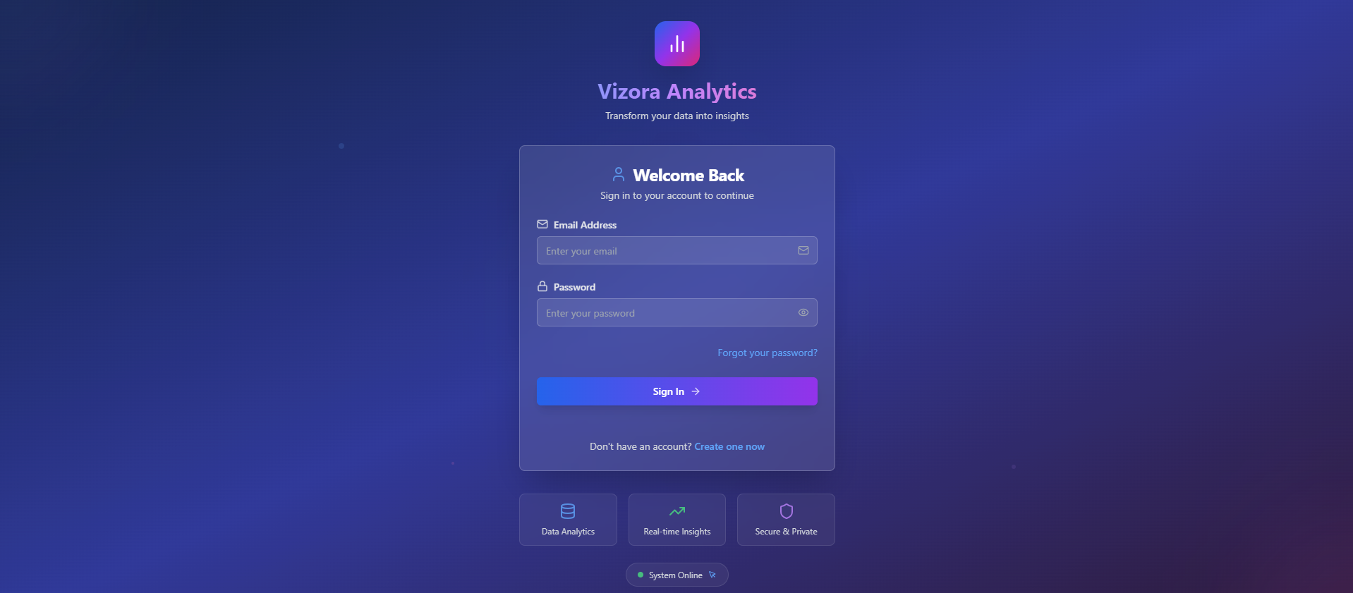

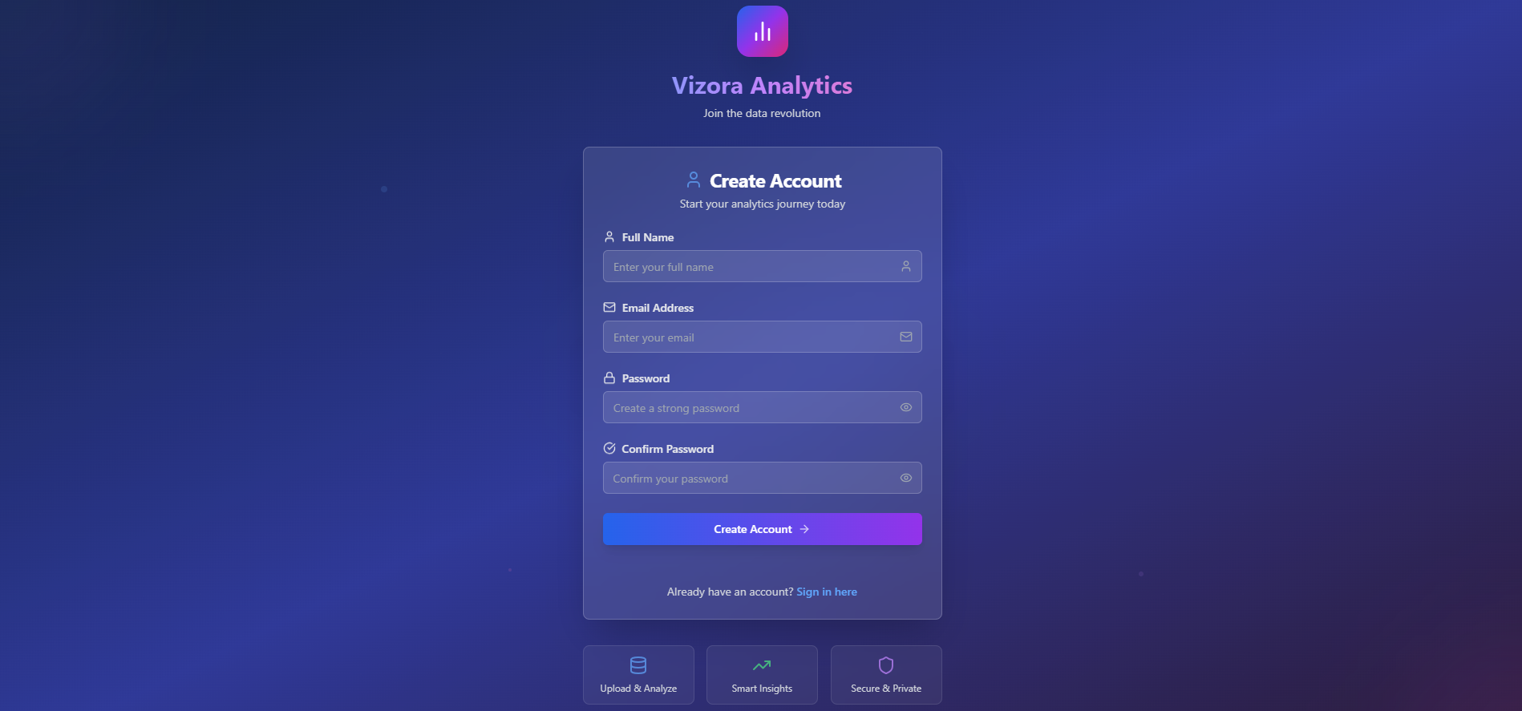

**8.2 User Dashboard**

* Displays total uploaded files and charts created.
* Shows recent activities like last uploaded file and generated chart.
* Includes performance metrics and system usage highlights.

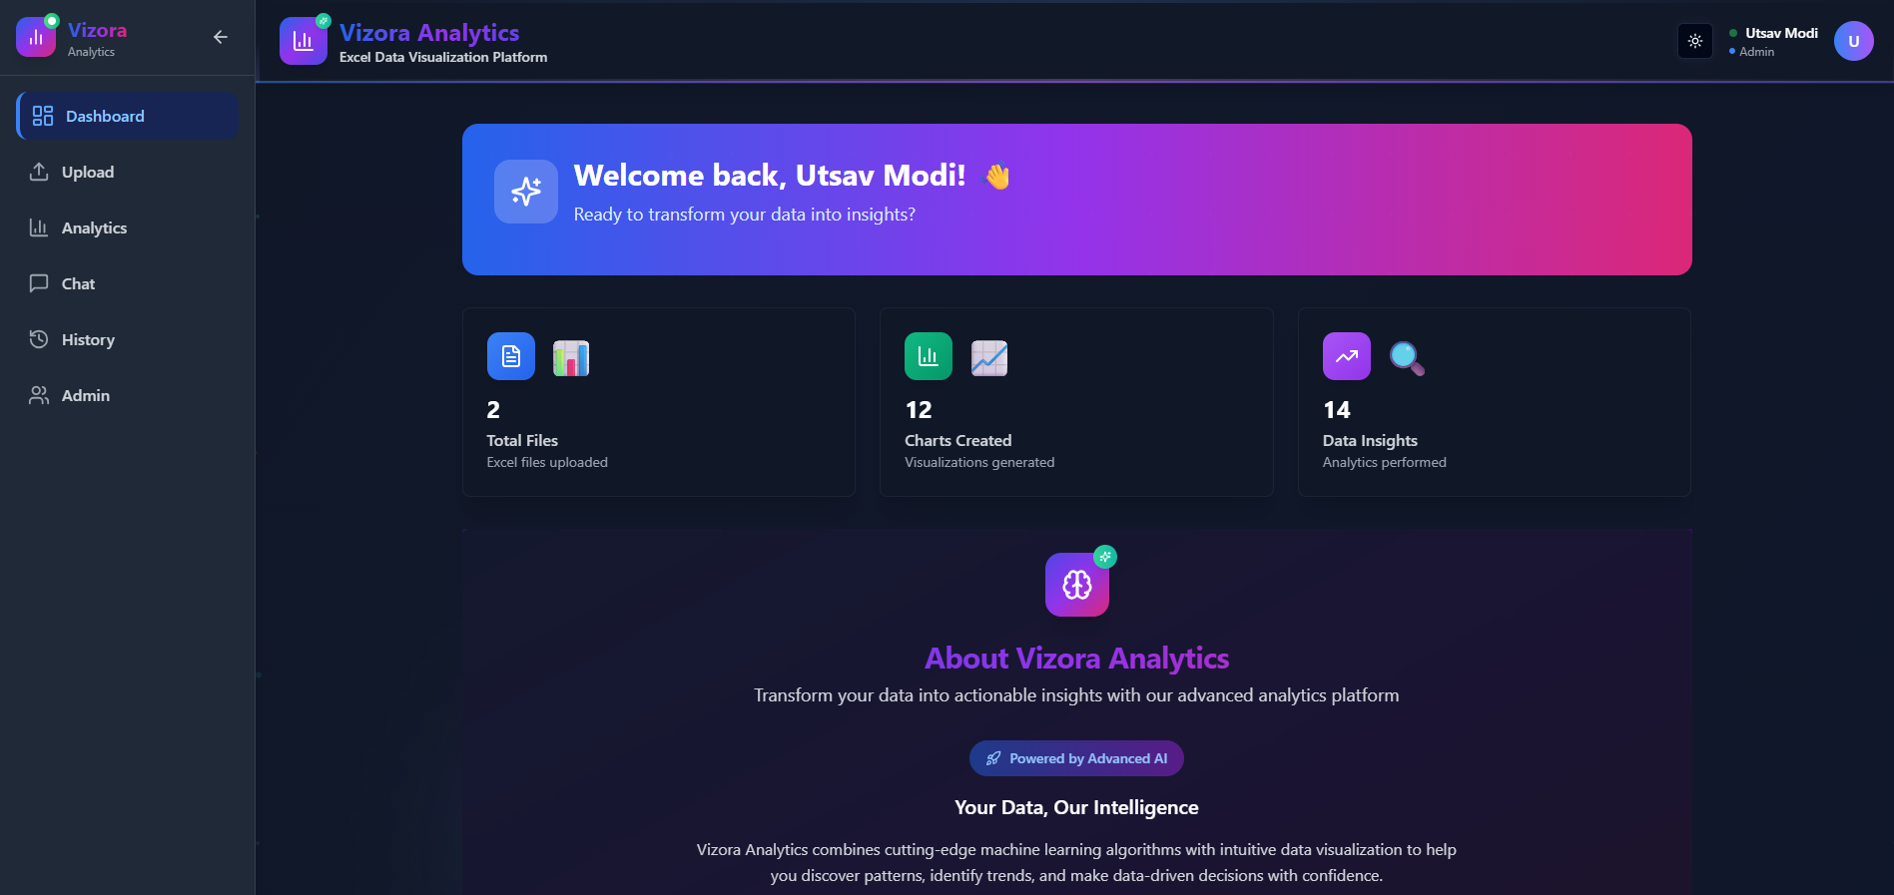

**8.3 File Upload Interface**

* Drag-and-drop or file select area for uploading .xlsx, .xls, or .csv files.
* Displays supported file types and instant preview of parsed data.

*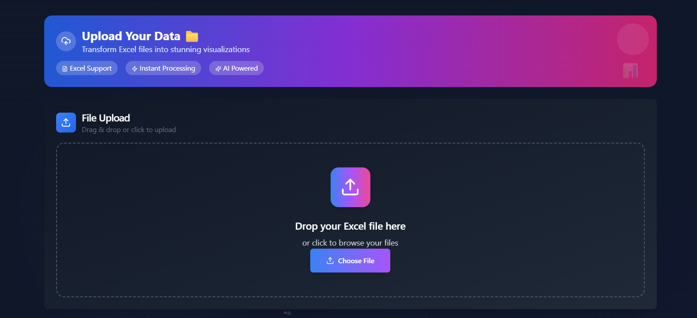***8.4 Analytics & Chart Configuration**

* Interface to select 2D or 3D chart types.
* Drop-down menus for X/Y axis selection.
* Chart rendered instantly based on user configuration.

*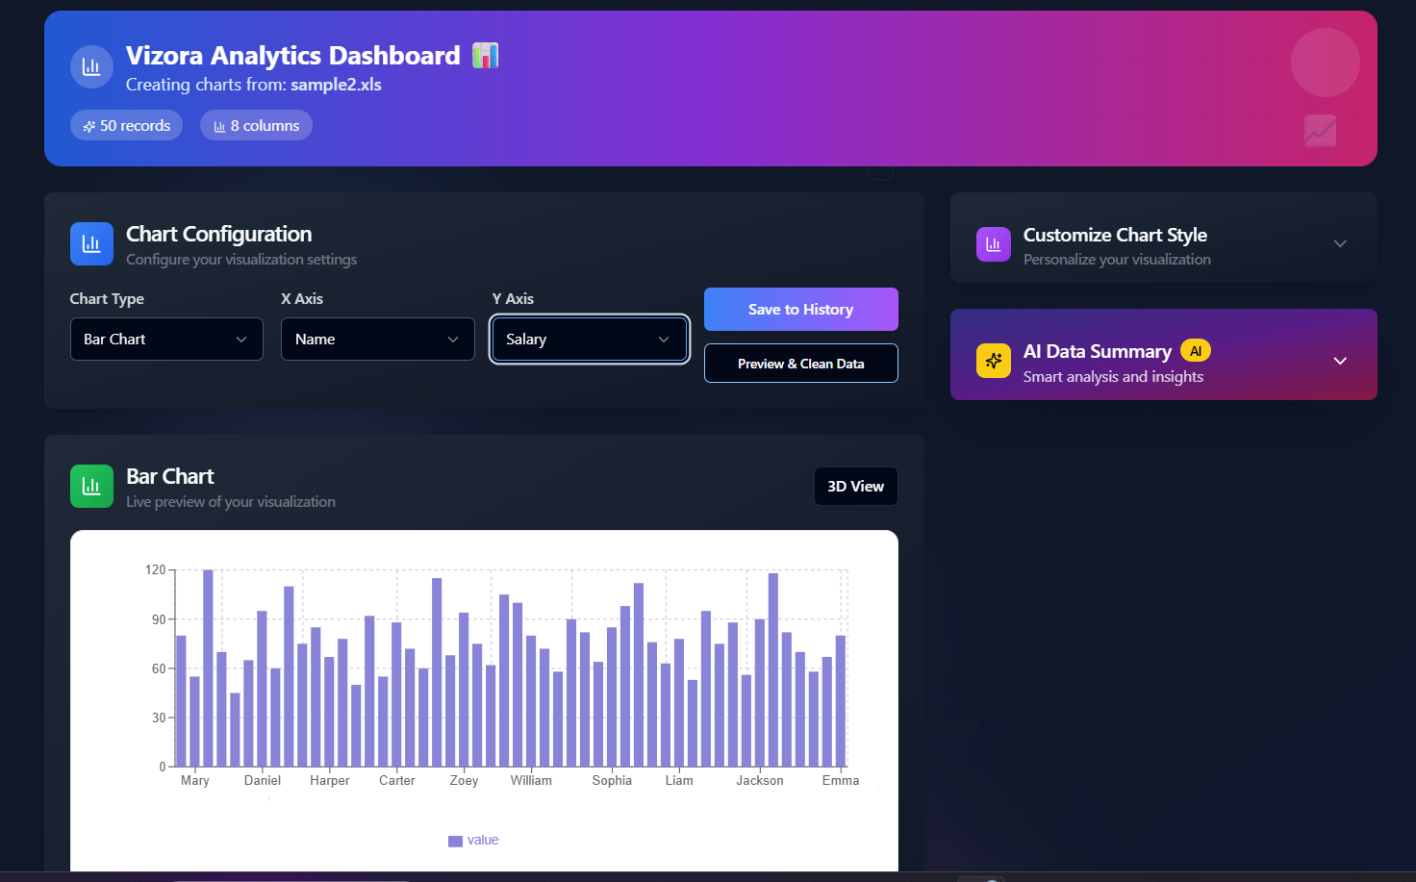***8.5 AI Insight Chat Section**

* Conversational UI for data summary, trend analysis, outlier detection, and chart suggestions.
* Responses are displayed dynamically alongside the dataset.

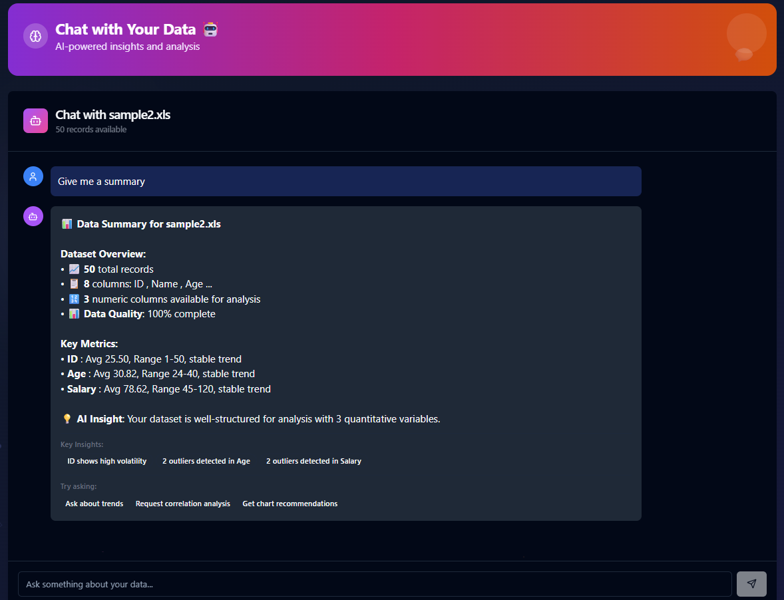

**8.6 History and File Re-access**

* Lists all previously uploaded files and created charts.
* Clicking on any file or chart restores it for reuse or editing.

*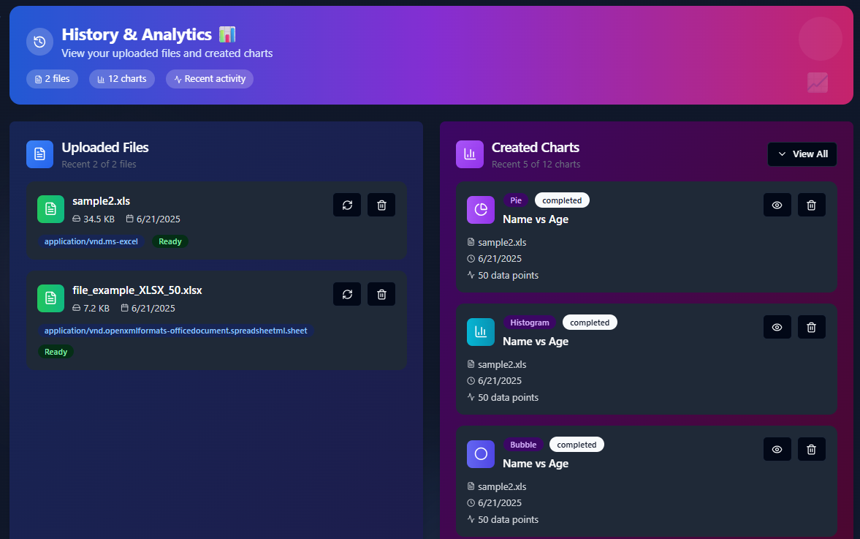***8.7 Admin Dashboard**

* Displays total users, active users, chart usage stats, and user management tools.
* Admins can view user roles, block users, and monitor activity.

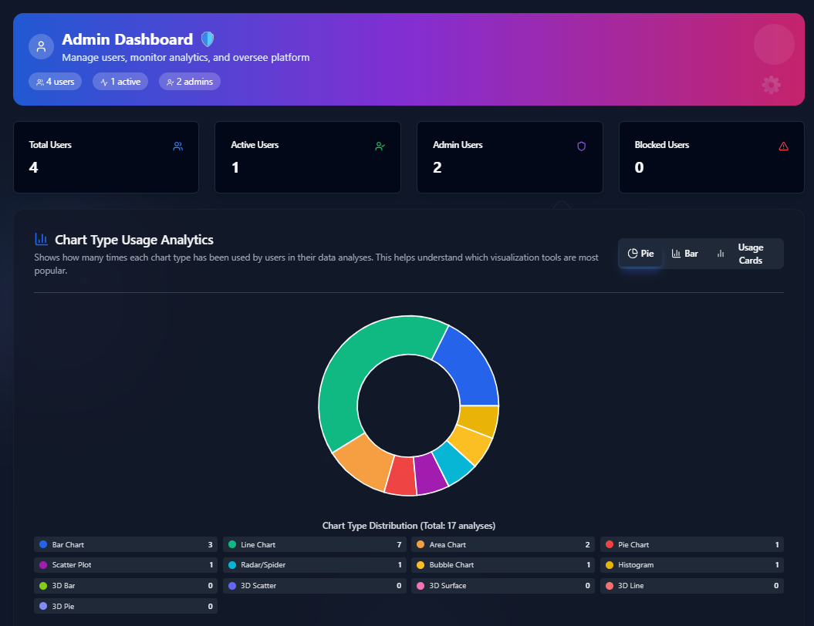

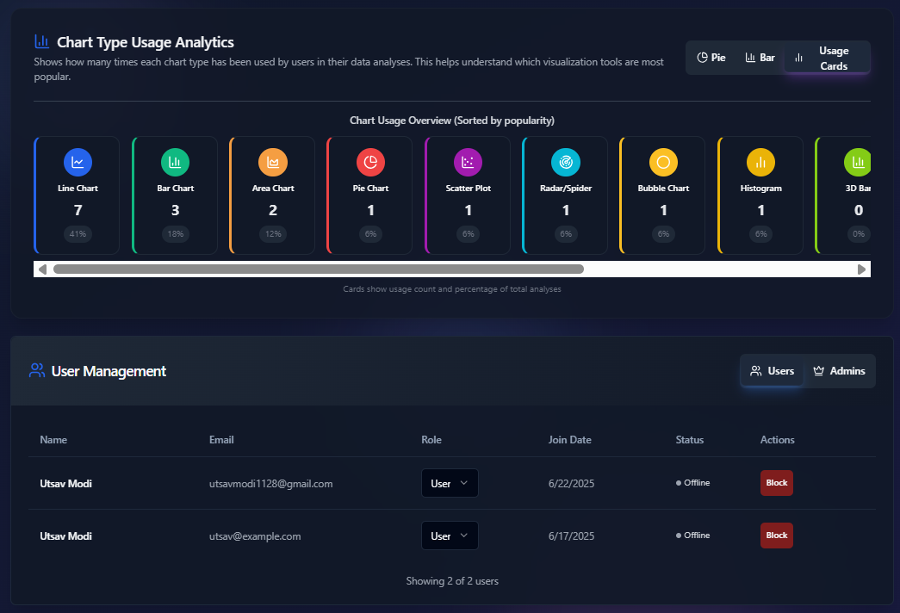**8.8 Profile and Settings**

* Allows users to update name, email, and change password.
* Option to toggle dark/light mode and manage notifications.

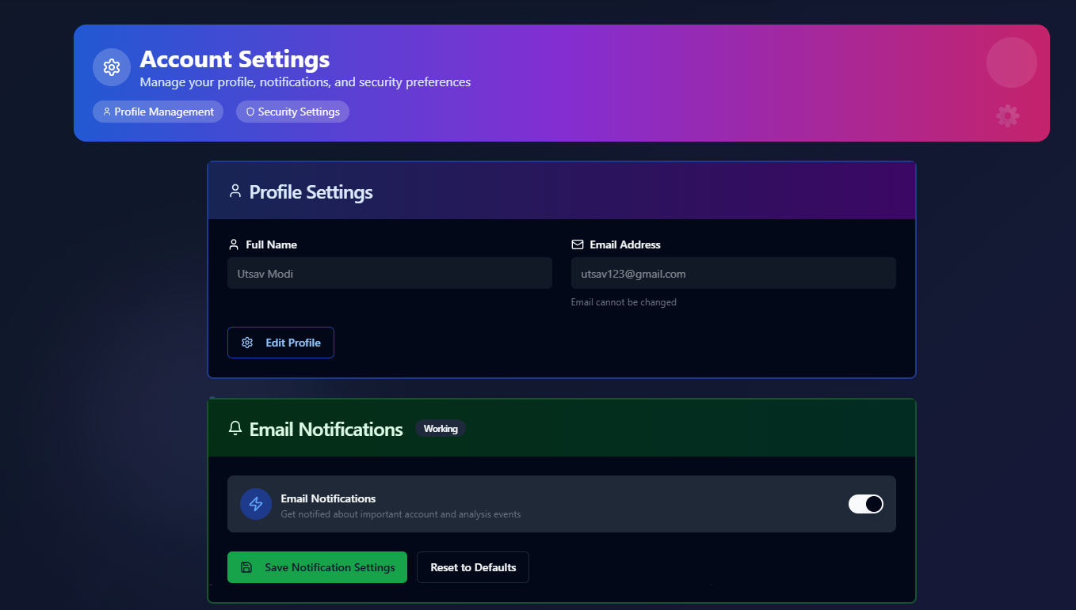

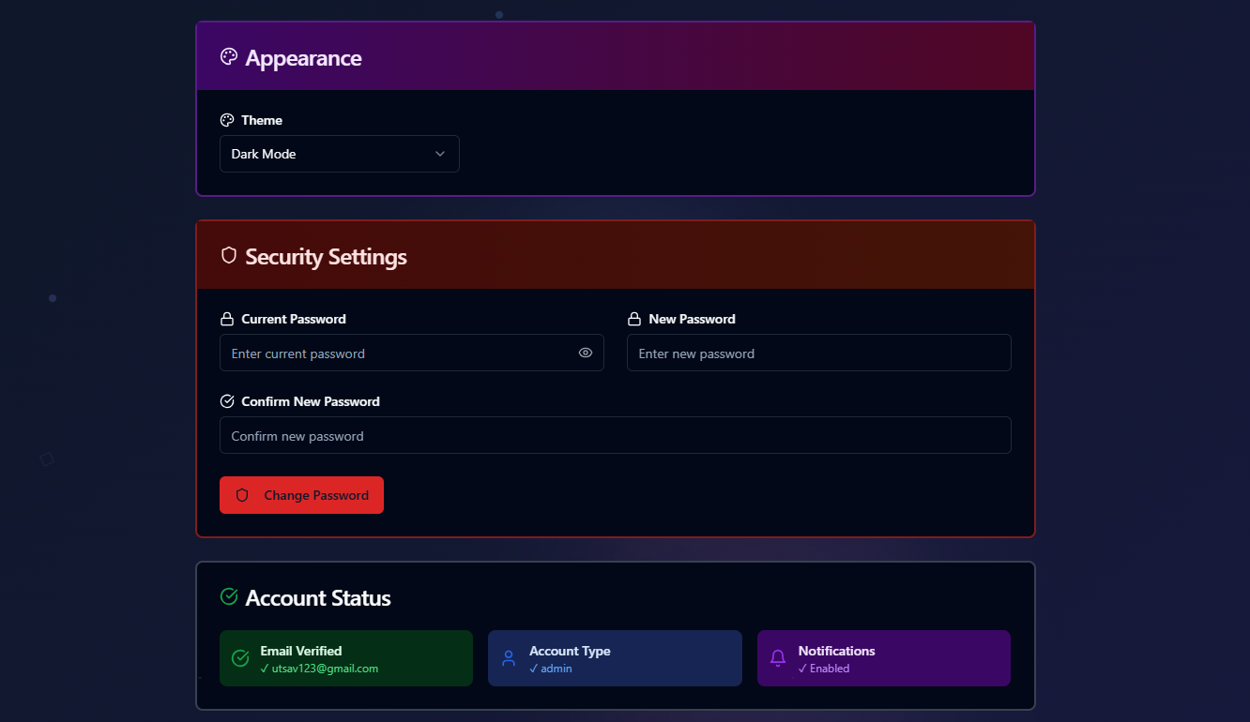**8.9 Theme Toggle (Light/Dark Mode)**

* Switch between dark and light themes with persistent preferences.
* Improves accessibility for different lighting environments.

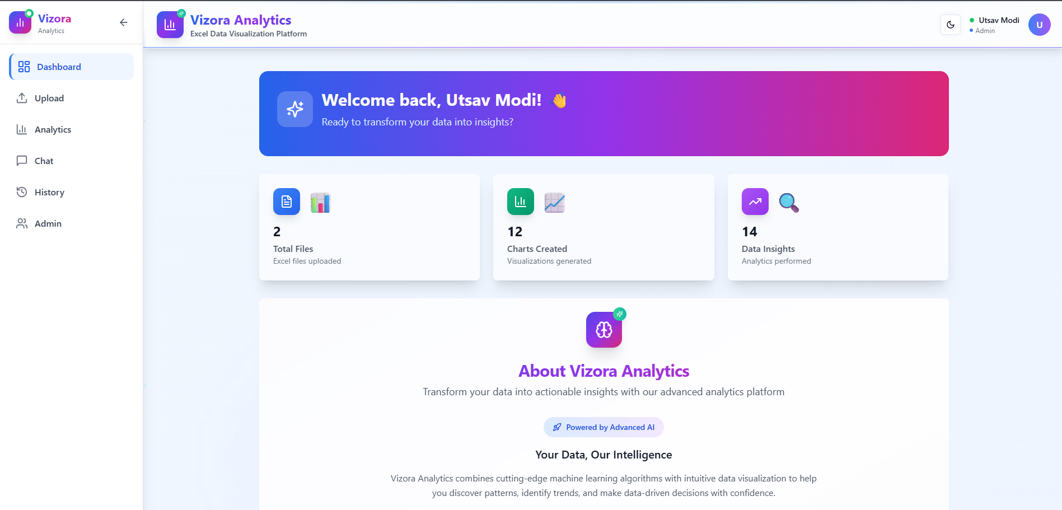

**Chapter 9 - Challenges Faced**

During the development of Vizora, several technical and design-related challenges were encountered. These challenges were addressed through research, testing, and iterative improvements to ensure a stable and user-friendly platform. Below are the key difficulties faced across different stages of the project:

**9.1 File Parsing and Format Handling**

* Supporting multiple file formats like .xlsx, .xls, and .csv required handling various encoding standards and data structures.
* Some Excel files had inconsistent cell formatting or merged rows, which caused issues during client-side parsing using SheetJS.
* Ensuring uniform parsing results across different file types required additional validations and fallbacks.

**9.2 Chart Configuration Flexibility**

* Designing a chart configuration system that works across different chart types (2D/3D) and datasets was challenging.
* Users could upload unpredictable datasets with varying columns, missing values, or incompatible data types.
* Ensuring that axis mapping, chart rendering, and customization options stayed intuitive for all chart types required thoughtful UI planning.

**9.3 AI Insight Logic**

* Developing insight functions like trend analysis and outlier detection using only frontend or lightweight backend logic required crafting custom algorithms without relying on heavy libraries.
* Suggesting the best chart types based on dataset patterns also required column type detection and heuristic analysis.

**9.4 User Data Isolation and Security**

* Ensuring that each user’s data remained private and inaccessible to others was critical.
* Implementing JWT-based authentication securely and integrating it with route protection took significant backend planning.
* User sessions, file history, and chart access needed strict ownership checks at every level.

**9.5 Admin Role Separation**

* Creating a separate admin workflow while keeping it isolated from regular users posed structural design challenges.
* Ensuring admin-only access to dashboards, user lists, and usage analytics involved protected routes and role-based access controls.

**9.6 Theme and Responsiveness**

* Implementing both light and dark themes while keeping all charts, tables, and components visually clear in both modes took additional styling effort.
* Maintaining UI responsiveness across screen sizes (desktop, tablet, mobile) required careful use of Tailwind CSS classes and layout testing.

**9.7 Real-Time Interactivity**

* Achieving a smooth, real-time chart rendering experience without performance lag was especially challenging for large datasets or 3D charts.
* Optimizations were necessary to prevent re-renders, excessive DOM updates, and memory issues when switching between charts.

**Chapter 10 - Future Enhancements**

While Vizora provides a comprehensive set of features for spreadsheet-based data visualization and AI-powered analysis, several potential improvements have been identified to further enhance functionality, performance, and user engagement. These future upgrades aim to make the platform more intelligent, scalable, and enterprise-ready.

**10.1 Export Options for Charts and Reports**

* Allow users to download generated charts as images (PNG, SVG) or embed them into PDFs.
* Provide automated report generation including data summaries, charts, and AI insights in a downloadable format.

**10.2 Collaboration and Sharing Features**

* Enable users to share charts or dashboards with other users or teams.
* Add permission controls (view/edit) for collaborative access.

**10.3 Real-Time Analytics**

* Introduce support for streaming data or real-time analytics where charts update live as new data comes in.
* Useful for monitoring dashboards and time-sensitive data scenarios.

**10.4 Dataset Annotation and Notes**

* Allow users to add notes or comments on specific datasets or charts.
* Help document important insights, observations, or instructions during analysis.

**10.5 Advanced AI Capabilities**

* Integrate more advanced AI models to perform deeper insights such as forecasting, clustering, or data classification.
* Expand the AI assistant’s ability to answer natural language questions about the dataset.

**10.6 Mobile App Support**

* Build a mobile-friendly version or dedicated app for Android/iOS to enable on-the-go data access and chart viewing.

**10.7 Integration with Cloud Storage**

* Allow direct file upload from services like Google Drive, Dropbox, or OneDrive.
* Streamline the upload process for users already storing data in the cloud.

**10.8 Audit Logs and Admin Alerts**

* Introduce detailed logging of user actions and file changes for administrative tracking.
* Notify admins of suspicious activity or failed logins via email or dashboard alerts.

**10.9 Multi-Language Support**

* Implement localization to support different languages such as Gujarati, Hindi, or global languages.
* Improve accessibility and adoption across diverse user bases.

**10.10 Plugin and Extension System**

* Allow third-party developers or power users to build plugins or custom chart types, extending Vizora’s capabilities.

**Chapter 11 – Conclusion**

Vizora is a powerful and user-friendly web-based analytics platform designed to simplify the process of data visualization and analysis for users of all technical levels. It integrates key functionalities such as file upload, customizable chart generation, AI-powered insights, and user history management within a secure and responsive environment.

The platform's modular architecture ensures scalability, while its use of modern web technologies like React, Node.js, and MongoDB provides robust performance. The addition of intelligent features—such as automatic trend analysis, outlier detection, and chart recommendations—enables users to make data-driven decisions quickly and accurately.

Through the implementation of secure authentication, role-based access control, and user-specific data management, Vizora maintains high standards of data privacy and protection. The admin dashboard and theme personalization features further enhance system usability and control.

Although the current version meets its core objectives, several future enhancements have been identified to extend Vizora’s capabilities, including real-time analytics, collaborative features, and integration with cloud services.

Overall, Vizora demonstrates how modern web technologies combined with intelligent automation can democratize data analytics and offer accessible solutions for individuals, professionals, and organizations alike.